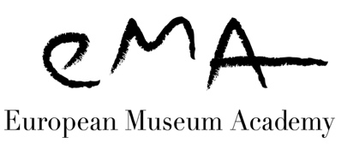
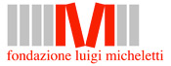
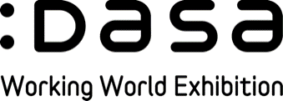

THE 2019 EUROPEAN MUSEUM ACADEMY AWARDS

LUIGI MICHELETTI AWARD & THE DASA AWARD

PUT YOUR MUSEUM CENTRE STAGE!

TODAY’S EUROPEAN MUSEUM EXPERIENCE!

Apply today, don’t miss the chance to profit from the visibility and networking opportunities offered to your museum by taking part in the European Museum Academy Awards. Hundreds of museums have already done so in more than 20 years of activity of the Micheletti Award. Candidates also have the opportunity of running for the DASA Award. Candidates will be visited by EMA qualified experts and presented at the Annual EMA Meeting in Ljubljana, Slovenia, 19-21 September 2019.

The EMA judges

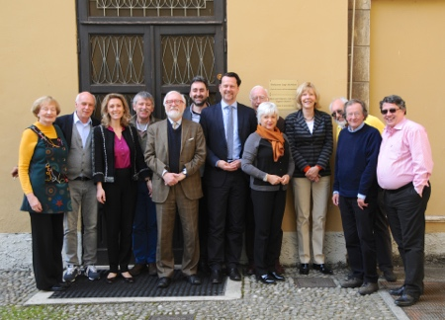
European Museum Academy
A European Museum Expertise Foundation
Kanaalweg 46,

2584 CL, The Hague – The Netherlands
Chairman’s office: Tel.0031 703515160; Director’s office: Tel. 0039 0289775567
europeanmuseumacademy@gmail.com
www.europeanmuseumacademy.eu
Registration number: 27359130 Chamber of Commerce, The Hague

THE EUROPEAN MUSEUM ACADEMY

EMA is a non-profit Foundation established to reflect museums at the international level, to promote research on museography and museology as a high cultural activity, to provide constructive criticism and promote discussion on new exhibitions and museums, and to diffuse museological knowledge and ideas among members of the profession. It aims to promote the conception and development of new as well as of traditional museums as tools of social change. Thirty-eight countries are currently represented within the EMA organisation. www.europeanmuseumacademy.eu

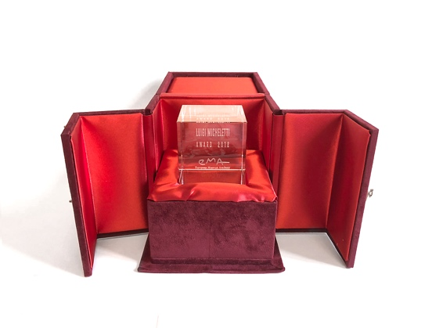
THE LUIGI MICHELETTI FOUNDATION (Fondazione Biblioteca Archivio Luigi Micheletti) LMF (established in 1981 in Brescia) is a research centre specialising in 20th-century history. Scientific research covers ideologies of the 20th century, wars, the ambivalence of technical progress, industrialization and labour, conspicuous consumption, the origin of environmentalism. The ideological, social and material contemporary history, led by international researches and conferences, is linked to a rich collection: writings, postcards, photos, posters, videos, audio documents, but also objects, furniture and machines. It is in this context that the musil – Museum of Industry and Labour – was created, in order to focus on the recovery of productive plants and whole urban areas.
www.fondazionemicheletti.eu - www.luigimichelettiaward.eu

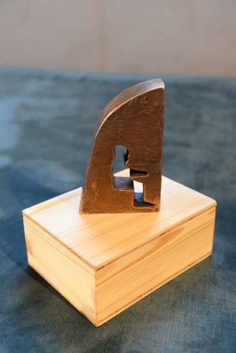
DASA WORKING WORLD EXHIBITION (DASA Arbeitswelt Ausstellung) DASA in Dortmund covers the past, present and future worlds of work in an area of about 13.000 m², with 12 exhibition units and three-dimensional exhibits. It is the permanent educational facility of the Federal Institute for Occupational Safety and Health Care (Bundesanstalt für Arbeitsschutz und Arbeitsmedizin) and informs the general public about the world of work, its status for the individual and society, and the importance of tailoring work to human requirements. The relationship between people, work and technology is demonstrated and explained in a variety of ways in the exhibition. The central theme is to establish human values at work, such as good health and dignity. DASA focuses on people and their physical, intellectual, social and cultural needs.
www.dasa-dortmund.de

CRITERIA FOR ENTRY

The Luigi Micheletti Award
This is an Award focused on contemporary European history and its scientific, industrial and social heritage. You may apply if you are a museum of 20th-century history (military political or social), a museum of science, technology or industry, a science centre, an ecomuseum, or an interpretation centre on these subjects and emerging crucial issues of contemporary society.

The DASA Award
The basic criterion of this award is the quality of learning opportunities, in a comprehensive perspective: the museological concept, the quality of the storyline, the creativity of the exhibition design and the programme of educational activities. Specific attention is also given to personal mediation, the interactive participation of the public and an effective mix of education and entertainment.
This Award is open to all kinds of museums.

ENTRY FEE

The completed application should be accompanied by an entry fee of 200 € (two hundred Euros), paid by bank transfer. Transfer charges must be paid by the applicant. Please make sure that your payment can be identified and include a copy of the transfer instructions with your application.

Bank: ING Bank
Address: Postbus 94780, 1090 GT Amsterdam, The Netherlands
Account name: European Museum Academy
Account number: 4682823
IBAN: NL36INGB0004682823
BIC/SWIFT: INGBNL2A

SUPPORTING MATERIAL

Preferably via WeTransfer to Dr Arno van Berge Henegouwen at arnovbh@xs4all.nl AND to Ann Nicholls, EMA Co-ordinator at ann.n1493@gmail.com. Please note that all future correspondence should be sent to Ann Nicholls. The other mail address is for this purpose only. Please let us know if for any reason you are not able to use WeTransfer.

- The completed Entry Data page (Word format).
- Two typewritten pages (Word format) in English describing the museum, its organisational structure, its method of financing and the European relevance or innovative aspects.
- Candidates are invited to show evidence that they fulfil the criteria of the Luigi Micheletti Award.
- Applicants are invited to document the fulfilment of the criteria of the DASA Award.
- Up to 20 images in JPEG format, no larger than 2 MB each. One exterior of the building with its name clearly displayed, general views of the exhibitions and images which illustrate your strong candidature for the Award. Films should not be more than five minutes (links preferred). Pictures must be free of copyright and accompanied by a declaration which enables EMA to use them for non-commercial purposes in its printed materials, on the Internet as well as in training programmes.
- Scanned copies of a brochure, leaflet or other publicity material you wish to include.
- A copy of the bank transfer instructions.

ENTRY DATA

Full name of museum, in original language and in English:
Director:
Full postal address:
Telephone number, with country and area code:
E-mail and website
Type of museum/historic site/naturalistic site
Year the museum was opened:
Finance: public or privately financed?
Annual budget. Amount devoted to education and exhibitions:
Number of objects:
Exhibition and storage spaces (in m²):
Number of permanent employees:
Number of temporary employees or volunteers:
Opening times:
Number of visitors (latest available figures):
What aspect of your museum makes it a strong candidate for the Luigi Micheletti Award and/or the DASA Award?

The closing date for applications is 05 APRIL 2019. It would be very helpful if you could notify us of your intention to apply before sending your WeTransfers.
If you have any questions, please contact Ann Nicholls, EMA Co-ordinator
Tel +44 (0)117 973 7965; ann.n1493@gmail.com
europeanmuseumacademy@gmail.com; www.europeanmuseumacademy.eu

